The Industrial Revolution I

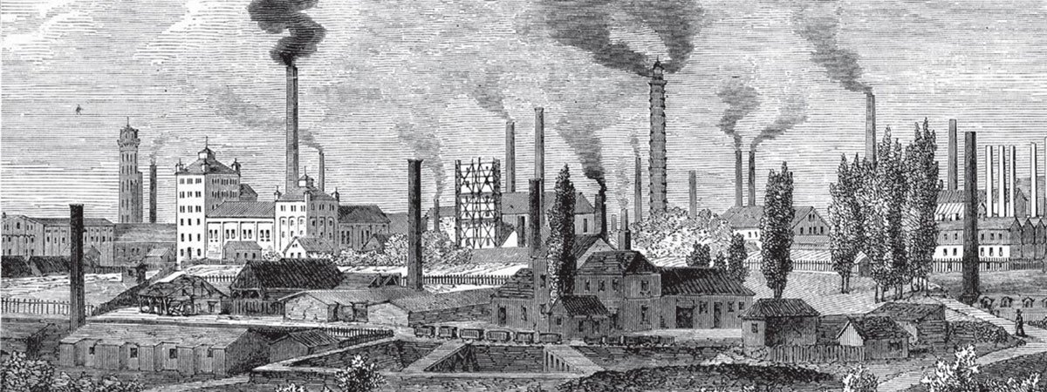

Read the text by using various reading strategies. While reading, there are some questions for you to answer (printed in Italics). You will also see some words that are underlined, these are words that are (probably) new to you. At the bottom of the text, you can find their translations in the glossary. To this list, you have to add some extra words that you don’t know yet. When looking for a translation, only use (online) dictionaries that are approved by your teacher. Do not use Google Translate.

Fossil Fuels, Steam Power, and the Rise of Manufacturing
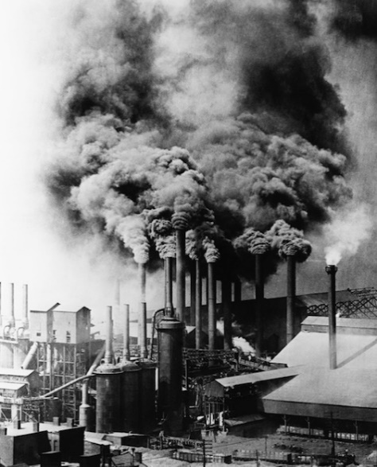
Source: https://www.khanacademy.org/partner-content/big-history-project/acceleration/bhp-acceleration/a/the-industrial-revolution

Abundant fossil fuels, and the innovative machines they powered, launched an era of accelerated change that continues to transform human society.

The Transformation of the World
Try to imagine what your life would be like without any machines working for you. Make a list of the machines in your household and on your person; you may arrive at a surprising number.
Make a list of the machines (and devices) you use daily:

Now imagine earlier generations during their childhood years. How did they move from place to place? How did they communicate? What foods did they eat?
What do you think? Type your answer:
At one time, humans, fuelled by the animals and plants they ate and the wood they burned, or aided by their domesticated animals, provided most of the energy in use. Windmills and waterwheels captured some extra energy, but there was little in reserve. All life operated within the fairly immediate flow of energy from the Sun to Earth.
Everything changed during the Industrial Revolution, which began around 1750. People found an extra source of energy with an incredible capacity for work. That source was fossil fuels — coal, oil, and natural gas, though coal led the way — formed underground from the remains of plants and animals from much earlier geologic times. When these fuels were burned, they released energy, originally from the Sun, that had been stored for hundreds of millions of years.
Coal was formed when huge trees from the Carboniferous period (345– 280 million years ago) fell and were covered with water, so that oxygen and bacteria could not decay them. Instead, the pressure of the weight of materials above them compressed them into dark, carbonic, ignitable rock.
Most of the Earth’s oil and gas formed over a hundred million years ago from tiny animal skeletons and plant matter that fell to the bottom of seas or were buried in sediment. This organic matter was compacted by the weight of water and soil. Coal, oil, and gas, despite their relative abundance, are not evenly distributed on Earth; some places have much more than others, due to geographic factors and the diverse ecosystems that existed long ago.
___________________________________________________________________________
Glossary:
English | Dutch | English | Dutch
Abundant | In overvloed | Capacity | Mogelijkheid
Launched | Lanceerde (zette in werking) | Remains | Overblijfselen
Fuelled by | Gevoed door | Compressed | Samengeperst
Aided by | Geholpen door | Ignitable | Ontsteekbaar
Flow of energy | Energiestroom | Sediment | Sediment (samengeperste lagen aarde)
Incredible | Ongelooflijk | Due to | Door

Add a few extra words you don’t know yet:
English | Dutch | English | Dutch

Exercise: summarise how the world has changed over time and how the Industrial Revolution played an important part in this transformation. Use your own words.
___________________________________________________________________________

Early Steam Engines
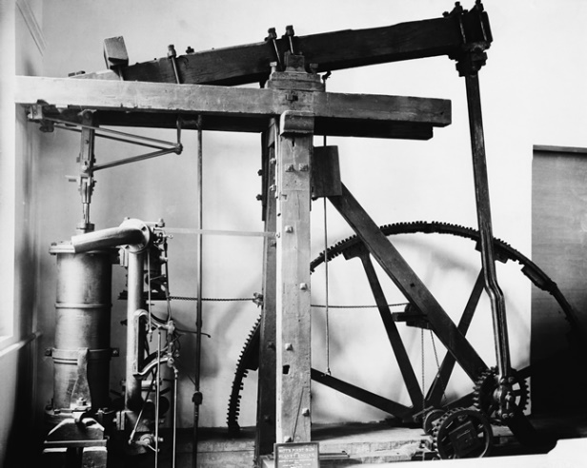
The story of the Industrial Revolution begins on the small island of Great Britain. By the early 18th century, people there had used up most of their trees for building houses and ships and for cooking and heating. In their search for something else to burn, they turned to the hunks of black stone (coal) that they found near the surface of the earth. Soon they were digging deeper to mine it. Their coalmines filled with water that needed to be removed; horses pulling up buckets full proved slow going.
To the rescue came James Watt (1736–1819), a Scottish instrument-maker who in 1776 designed an engine in which burning coal produced steam, which drove a piston assisted by a partial vacuum. (There had been earlier steam engines in Britain, and also in China and in Turkey, where one was used to turn the spit that roasts a lamb over a fire.) Its first application was to more quickly and efficiently pump water out of coal mines, to better allow for extraction of the natural resource, but Watt’s engine worked well enough to be put to other uses; he became a wealthy man. After his patent ran out in 1800, others improved upon his engine. By 1900 engines burned 10 times more efficiently than they had a hundred years before.

At the outset of the 19th century, British colonies in North America were producing lots of cotton, using machines to spin the cotton thread on spindles and to weave it into cloth on looms. When they attached a steam engine to these machines, they could easily out-produce India, up until then the world’s leading producer of cotton cloth. One steam engine could power many spindles and looms. This meant that people had to leave their homes and work together in factories.

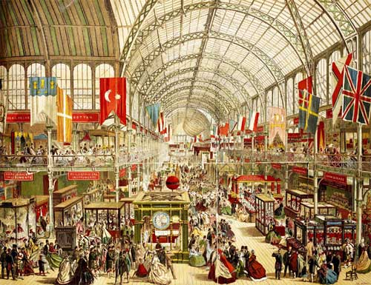
Early in the 19th century the British also invented steam locomotives and steamships, which revolutionized travel. In 1851 they held the first world’s fair, at which they exhibited telegraphs, sewing machines, revolvers, reaping machines, and steam hammers to demonstrate they that were the world’s leading manufacturer of machinery. By this time the characteristics of industrial society — smoke rising from factories, bigger cities and denser populations, railroads — could be seen in many places in Britain.
___________________________________________________________________________
Glossary:
English | Dutch | English | Dutch
Hunks | Stukken | Spindle | Spoel
Coalmines | Kolen mijnen | Weave | Weven
Piston | Zuiger | Loom | Weefgetouw
Partial vacuum | Deels vacuum | Revolutionized | Revolutionizeerde
Extraction | Onttrekking | Manufacturer | Fabricant
Colonies | Kolonien | Denser | Dichter

Add a few extra words you don’t know yet:
English | Dutch | English | Dutch

Questions: MAVO/HAVO/VWO
- Why did people need coal?

- What was the problem with the coalmines?

- What did James Watt do?

- Was his invention original?

- Why is the year 1800 an important year and what happened after that?

- How did the British colonies benefit from James Watt’s invention?

- How did James Watt’s invention influence people’s lives?

- What happened in 1851 and why was this important for Britain?

___________________________________________________________________________

Consequences of the Industrial Revolution
The statistics that reflect the effects of industrialization are staggering. In 1700, before the widespread use of fossil fuels, the world had a population of 670 million people. By 2011 the world’s population had reached 6.7 billion, a 10-fold increase in a mere 300 years. In the 20th century alone, the world’s economy grew 14-fold, the per capita income grew almost fourfold, and the use of energy expanded at least 13-fold. This kind of growth has never before occurred in human history.
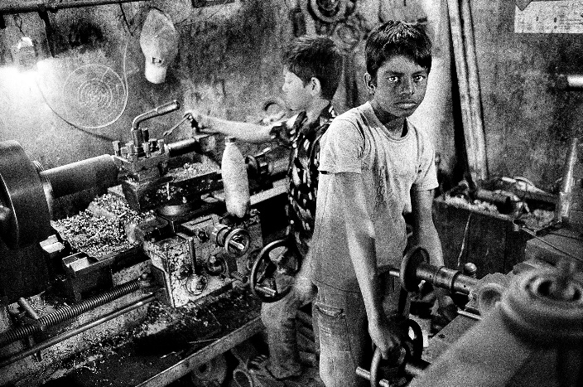
Many people around the world today enjoy the benefits of industrialization. With so much more energy flowing through human systems than ever before, many of us must do much less hard physical labour than earlier generations did. People today are able to feed more babies and bring them to adulthood. Many people vote and participate in modern states, which provide education, social security, and health benefits. Large numbers of people enjoy levels of wealth, health, education, travel, and life expectancy unimagined before industrialization.
The benefits of industrialization, however, have come at great cost. For one thing, the rate of change (acceleration) is now so rapid that individuals and social systems struggle to keep up. And strong arguments can be made about depersonalization in the age of mass production.
The increased complexity of the industrial system has also brought increased fragility. Industrialization depends on the interaction of many diverse components, any one of which could fail. We know that many of the essential components of the industrial system, and the natural resources it depends on, are being compromised — the soil, the oceans, the atmosphere, the underground water levels, plants, and animals are all at risk. Will growth continue unchecked, or are we approaching the end of an unsustainable industrial era? Whatever the future holds, we’ll be debating — and dealing with — the consequences of modernization for years to come.
___________________________________________________________________________
Glossary:
English | Dutch | English | Dutch
Reflect the effects | De effecten weergeven | Struggle | Worsteling, moeite hebben met
Staggering | Wonderbaarlijk | Depersonalization | Depersonalisatie, ontvreemding
Mere | Enkel | Complexity | Gecompliceerdheid
Per capita income | Inkomen per inwoner | Fragility | Breekbaarheid
Benefits | Voordelen | Essential components | Essentiele onderdelen
Physical labour | Lichaamelijke arbeid | Soil | Bodem, aarde
Social security | Uitkeringen | Unsustainable | Niet duurzaam
Life expectancy | Levensverwachting | Consequences | Gevolgen

Add a few extra words you don’t know yet:
English | Dutch | English | Dutch

Questions: MAVO/HAVO/VWO
- What became possible thanks to the Industrial Revolution?

- What are some of the benefits people experience because of the Industrial Revolution?

- What are some of the downsides related to the Industrial Revolution?

- Can you think of any other downsides or disadvantages related to the Industrial Revolution?

___________________________________________________________________________

